SAP iDC Reusable Repository

Type of Object – UI5/Fiori

Description – Create Gateway service to Display the List of Open Outbound Deliveries based on plant.

Process – P2P

DOCUMENT ORIGIN
AUTHOR | OPERATION UNIT
Rahul Tiwari | SAP – APPS TWO

CHANGE HISTORY
VERSION | DATE | CHANGES
1.0 | 26-08-2016 | Initial version

REVIEW AND APPROVAL
COMPANY | NAME | ROLE | DATE | SIGNATURE
Capgemini India Pvt. Ltd. | Suprio Chatterjee | Mentor | 22/8/2016

CONTRIBUTED BY
AUTHOR | OPERATION UNIT
Rahul Tiwari | SAP – APPS TWO

Introduction

Document Purpose

This document describes how to create ‘ABAP Gateway Service’ to display list of open outbound deliveries based on plant.
1.2 Benefit of Document:
Developer can directly use this ZGW_OUTBOUND_DELIVERY gateway service for List of Open Outbound Deliveries based on plant.

MAJOR FEATURES

Here the document describes the process step by step with screen shot to create ‘ABAP Gateway Service’ for displaying list of Open Outbound Deliveries for current Plant as Input parameter.

TECHNICAL DETAILs:

Step by Step process to create Gateway service

Step-1: Create RFC function Module which will return all the list of Open Outbound deliveries , Plant is given as input parameter. This RFC Function Module will be used in the gateway service creation.
Function Module creation and code for data retrieval is shown in the picture below-
Name of RFC Function Module- ZOUTBOUND_DELIVERY
Below is the code of RFC Function Module

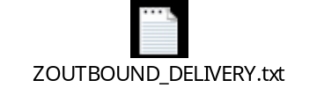
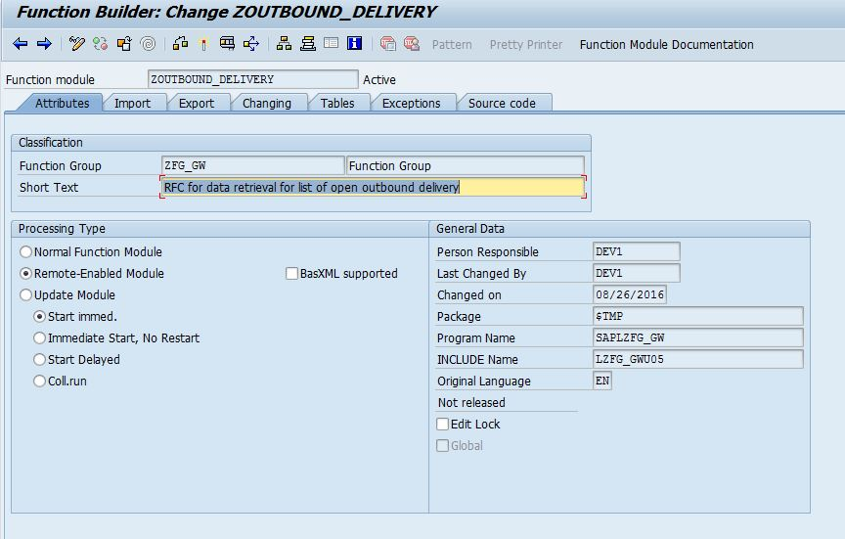
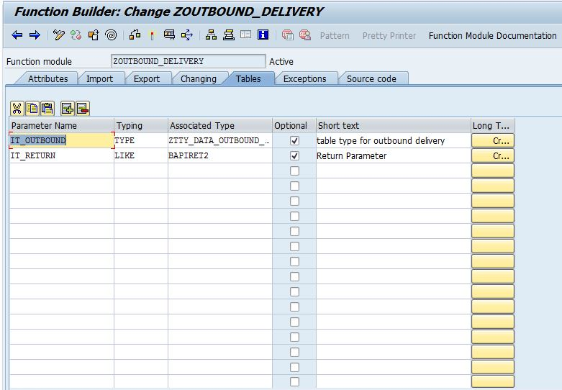

Step-2
Go to Transaction code SEGW to open the Gateway Service Builder

Step-3
Click on the Create project button
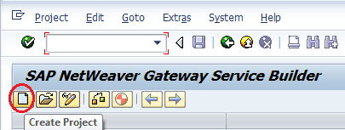

Step-4
Enter the project name and description and click on the continue button
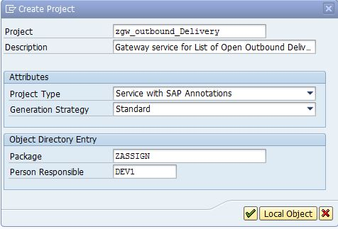

Step-5
Right click on the ‘Data Model’ and click on the menu ‘Import→ RFC/BOR Interface’ to create Entity Type and Entity Set by referring the RFC Function Module
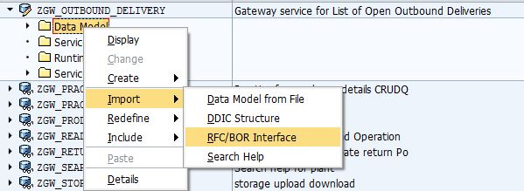
One popup wizard will open where enter the ‘Entity type name’, data source attributes type as ‘Remote Function Call’ and Name of the RFC function module and click on the ‘Next’ button
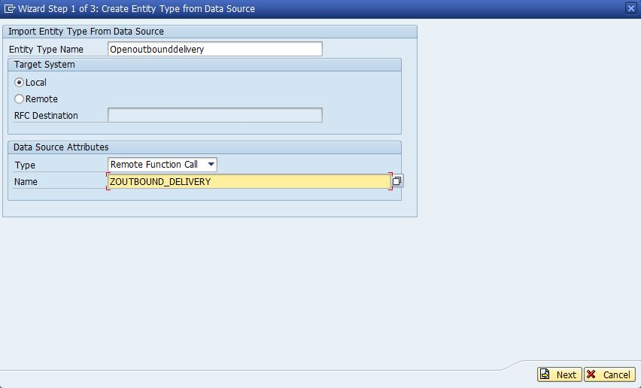

Step-6
Select all check boxes and click on the ‘next’ button
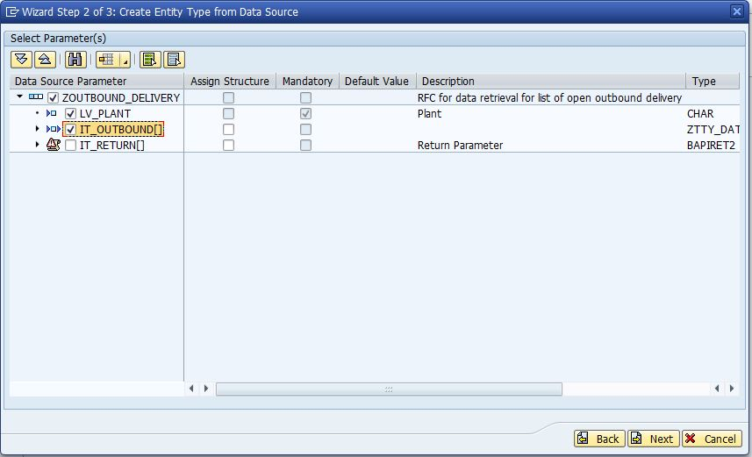
Step-7
Tick the key field in the ‘Is Key’ column and also Tick the check box ‘Create Default Entity Set’ and click the ‘Finish’ button
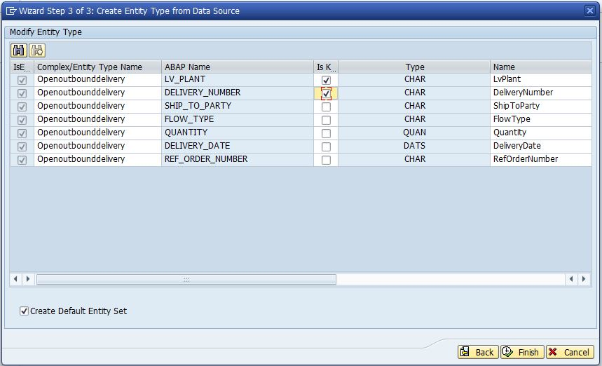
The ‘Entity Types’ and ‘Entity Sets’ will be created as below
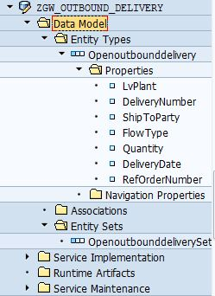
Double click on the ‘Entity Types’ properties and make the Plant, Ship to Party, Flow Type and Delivery Date as filterable.
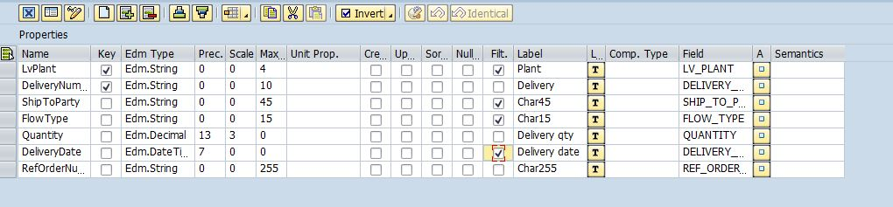
Step-8
Now Right click on the ‘GetEntitySet (Query)’ and choose ‘Map to Data Source‘
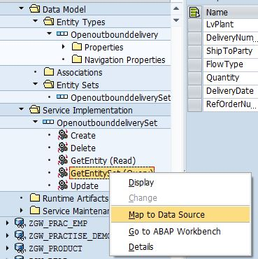
One popup will appear there enter the RFC Function Module Name and click on the continue button
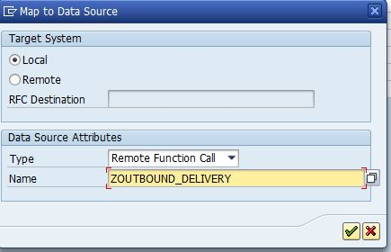
Step-9
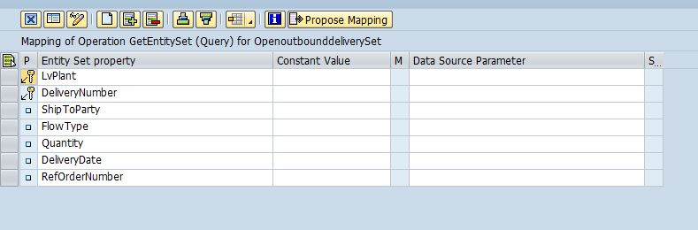
Click on the ‘Propose Mapping’ button to map the Gateway service parameter with the RFC Function Module
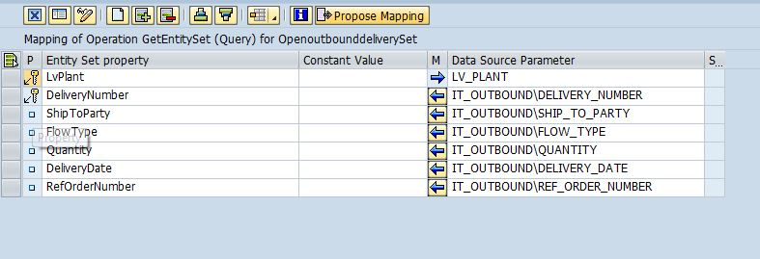

Step-10
Now click on the ‘Generate Runtime Services’ button
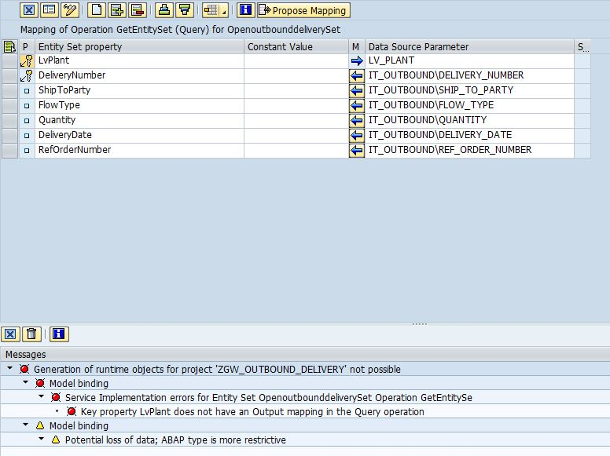
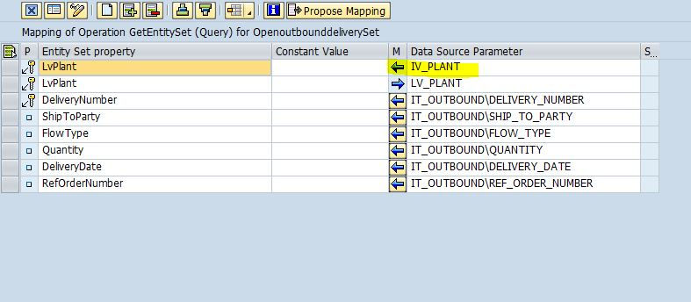

Step-11
Now click on the ‘Generate Runtime Services’ button
One popup will appear with ‘Model Provider Class’, ‘Data Provider Class’, ‘Technical Model Name’ and ‘Technical Service Name’. Here click the ‘continue’ button
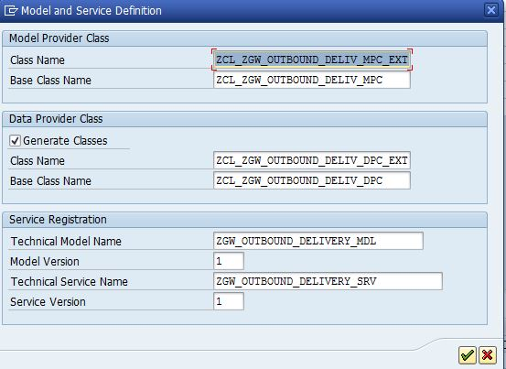
After click the continue button Gateway Service will be generated
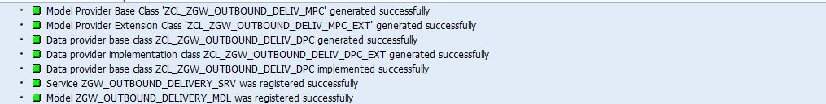

Step-12
Expand the ‘Service Maintenance’ and Double click on the ‘LOCAL’ and click on the ‘Register’ button and enter the system where to register and run the Gateway service
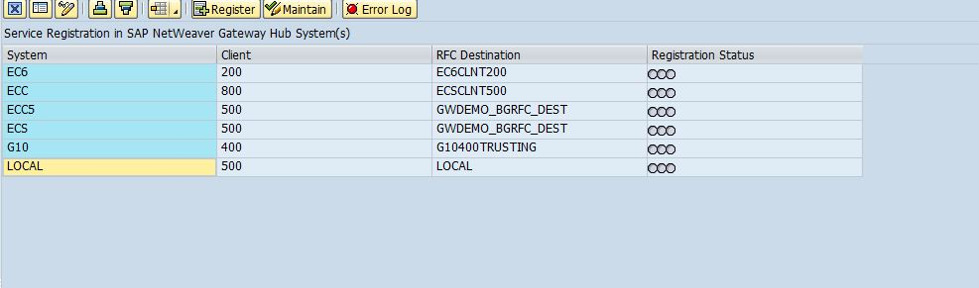
Click On Register and enter ‘LOCAL’ in system ALias
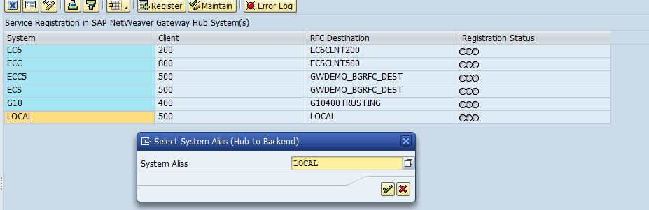
Enter the package name and click on the continue button
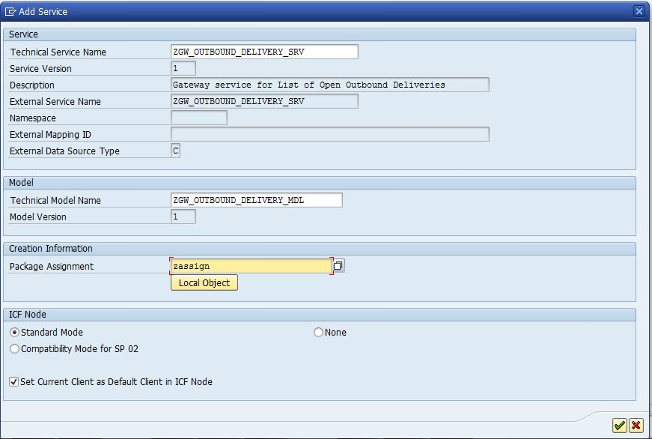
The Gateway Service is registered now and we can see the green symbol in registration status.
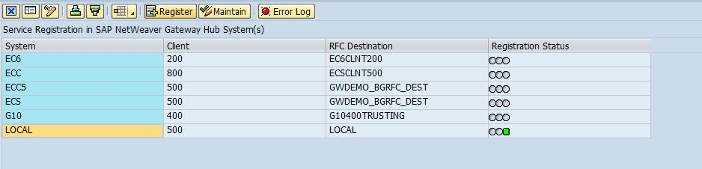

Step-13
Now click on the ‘Maintain’ button to test the gateway service and get the URI of the service
One popup will appear there choose the ‘Yes’ button

Now click on the ‘Gateway Client’ button
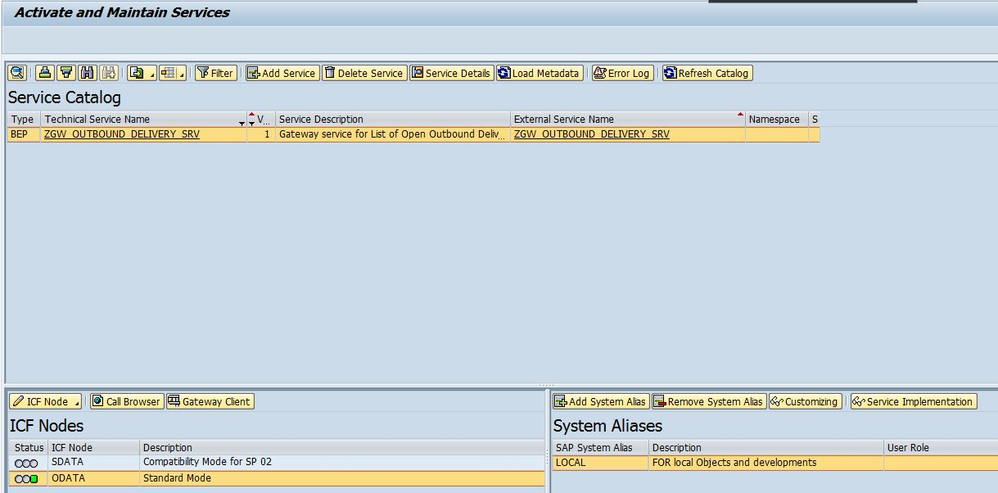
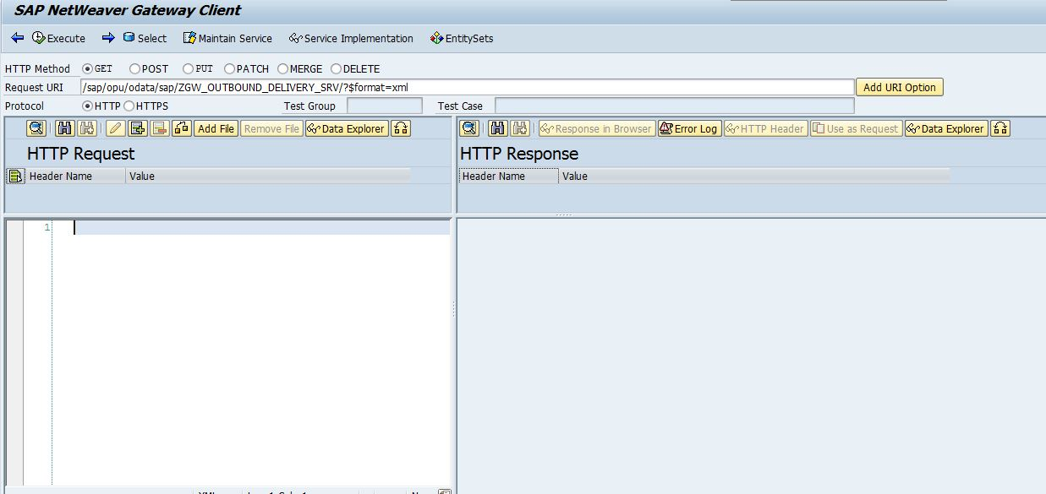
Change the URI: instead of ‘$format=xml’ in the URI enter ‘$metadata’ and execute to get the metadata
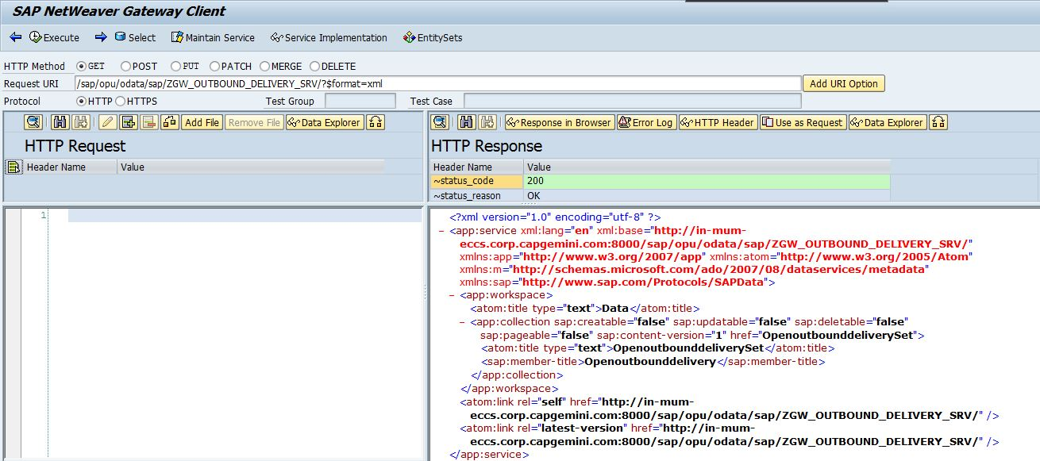
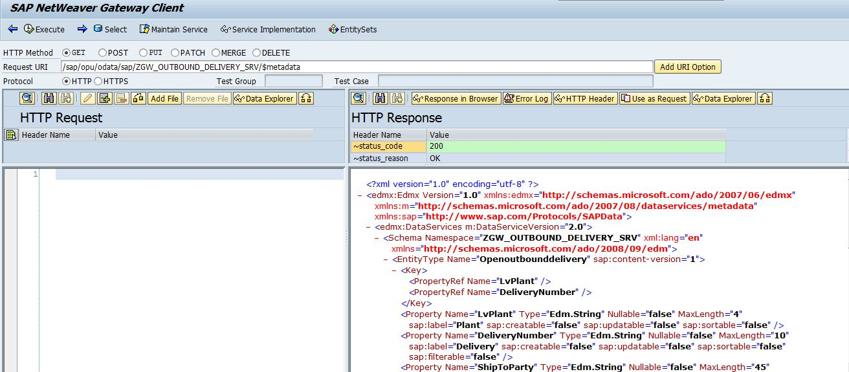
To get the parameterized query result, change the URI as below:
/sap/opu/odata/sap/ZGW_OUTBOUND_DELIVERY_SRV/OpenoutbounddeliverySet?$filter=LvPlant eq '0001'
Where ‘OpenoutbounddeliverySet’ is the Entity Set Name and LvPlant is the filter parameter.
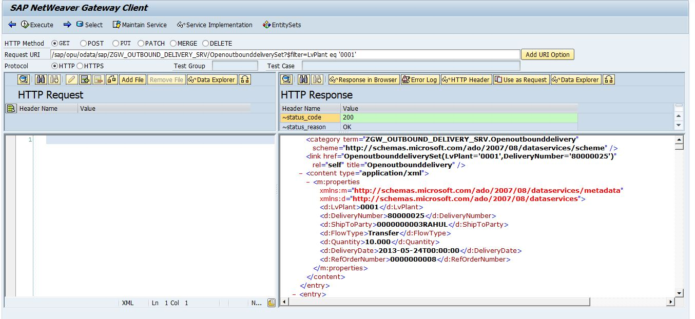

UNIT TEST CASE

As mentioned above

